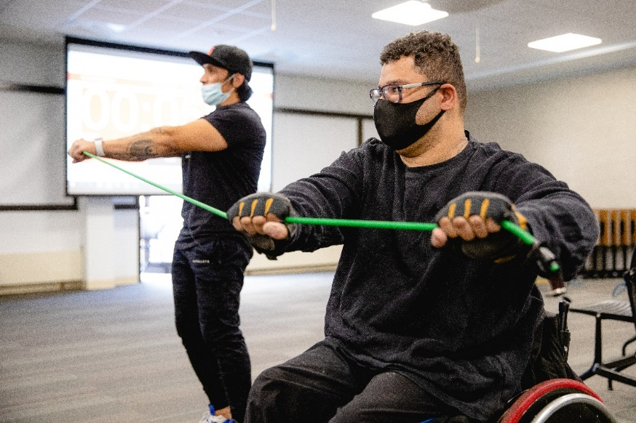

Exercise Class for people
with Visual Impairments

Mary Free Bed Wheelchair and Adaptive Sports is excited to offer an adaptive exercise class for people who live with visual impairments. Whether you are a beginner or experienced person who loves to exercise, this class will have something for you. This 6-week class will consist of aerobic exercises, strength exercises, and interval training for any level. Led by a certified personal trainer (NASM certified), exercises will be modified and adapted for each participant whether sitting or standing. Adaptive equipment will be available for participants. There will be volunteers to assist participants. Participants must be at least 16 or older to participate.

Dates: Fridays, February 3rd – March 10th
Times: 10am-11am
Location: ABVI Conference Room (456 Cherry St SE, Grand Rapids, MI 49503)
Cost: $40.
Register: Please call Mary Free Bed Wheelchair and Adaptive Sports at 616-840-8356 to register.

